**Cyclistic Capstone Data Analysis Report**

**Business Task** : To understand how annual members and casual riders use Cyclistic bikes differently.

**Data source**: We used 3 months of cleaned trip data from April, May, and June 2020.

**Cleaning steps**:

* - Added ride_length column by subtracting ended_at - started_at
* - Added day_of_week and day_name columns to know the day
* - Removed blanks and errors

**Pivot Table Insights**:

* - Casual riders ride longer on average than members
* - Members ride more consistently across weekdays
* - Casual riders are more active on weekends

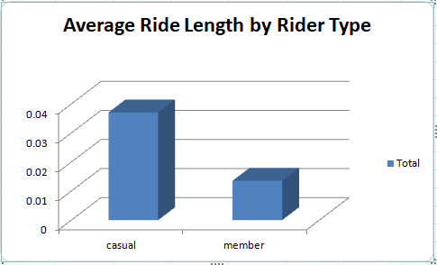

**Recommendations**:

* 1. Offer weekend discounts to casual riders
* 2. Send promotional emails about membership to frequent casual riders
* 3. Use social media ads on weekends to target casual riders